# DAILY ASSESSMENT

|  |  |  |  |
| --- | --- | --- | --- |
| **Date:** | **23-7-2020** | **Name:** | **Gaganashree P** |
| **Course:** | **salesforce** | **USN:** | **4al15ec024** |
| **Topic:** | **Data modelling and Leads & Opportunities for Lightning Experience** | **Semester & Section:** | **8th A** |
| **Github**  **Repository:** | **Gaganashree-P** |  |  |

|  |
| --- |
| **FORENOON SESSION DETAILS** |
| **Work with Schema Builder**  1. From Setup, search for and click Schema Builder in the Quick Find box.  Quick Find box location. |

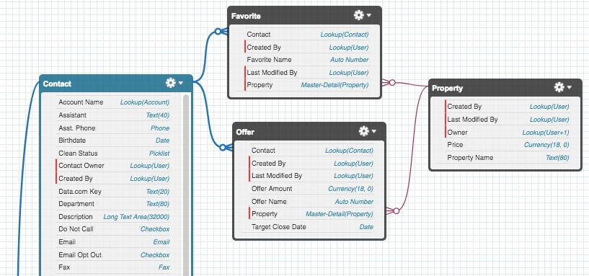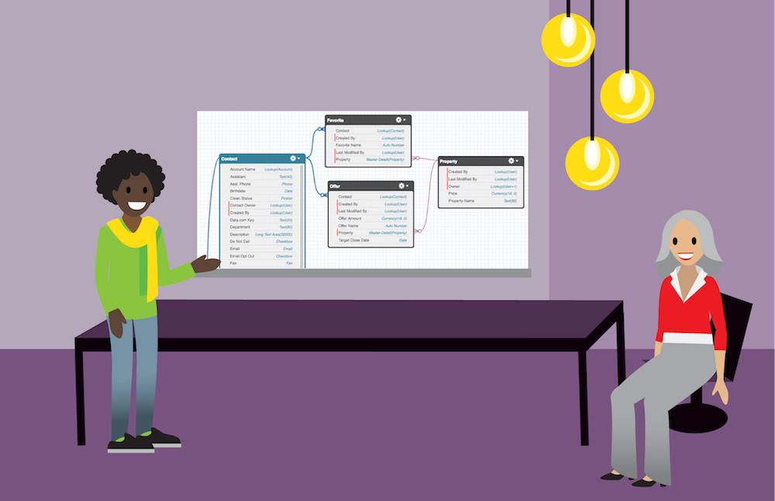

1. In the left panel, click Clear All.
2. Check Contact, Favorite, Offer, and Property.

You should have the Favorite object from the previous unit, and the Offer and Property objects from the previous challenges.

1. Click Auto-Layout. You'll see something like this:

Notice that you can drag these objects around the canvas. This doesn’t change your objects or relationships, but it can help you visualize your data model in a useful way. Schema Builder is a handy tool for introducing your Salesforce customizations to a co- worker or explaining the way data flows throughout your system.

## Create an Object with Schema Builder

Schema Builder is great for visualization, but you can also use it to customize your data model. For example, you can manage the permissions for your custom fields directly in Schema Builder. Just right-click the field name and click Manage Field Permissions.

You can also create objects using Schema Builder. If you prefer, you can create objects in this visual interface if you’re designing your system and want to be able to revise all your customizations on the spot. Let’s see how it’s done.

1. In the left sidebar, click the Elements tab.
2. Click Object and drag it onto the canvas.
3. Enter information about your object. You can make it whatever you want!
4. Click Save.

Your new object appears in the Schema Builder. That was quick! Next, let’s add some fields.

## Create Fields with Schema Builder

Creating fields with Schema Builder is just like creating objects.

1. From the Elements tab, choose a field type and drag it onto the object you just created. Notice that you can create relationship fields, formula fields, and normal fields in Schema Builder.
2. Fill out the details about your new field.
3. Click Save.

Cool! If you go back through Object Manager, you’ll see your new object shows up the same way your Property, Offer, and Favorite objects do.

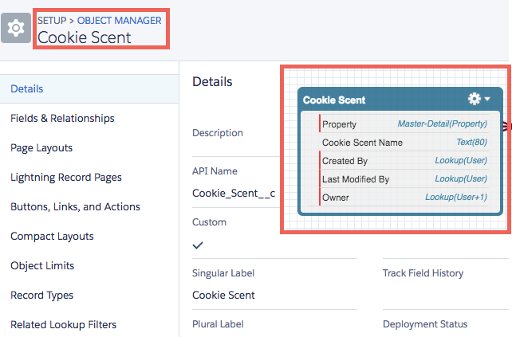

## Sum It Up

We’ve learned a lot in this module. First, we talked about the data model and the database. We covered objects, fields, and records and created some of each for our DreamHouse app. Then we talked about relationships between objects and how you can visualize your data model using Schema Builder.

As you start to dive into more advanced content, you’ll see custom objects and fields everywhere. Before you know it, you’ll be a data modeling pro. Happy building!

# Work Your Opportunities

## Opportunities

Opportunities are deals in progress. In Salesforce, you can create opportunities for existing accounts or by converting a qualified lead. Let’s explore how you can use opportunities to track your deals, better understand who you’re selling to, and focus your team’s efforts.

## Opportunity Stages

If you’ve worked in sales, you know that deals usually progress from tentative to firm before they’re finalized. As a deal progresses, you grow more confident of making the sale. In Salesforce, an opportunity moves through a series of stages linked to the types of tasks being performed, and the likelihood of completing the sale.

The stages you usually go through can look like this.

* Prospecting
* Proposal/Price Quote
* Negotiation/Review
* Closed/Won
* Closed/Lost

You had a meeting with Leung and Alan from Get Cloudy Consulting. They’re interested in buying sneakers from a couple of different product lines. You still have a lot of work to do to close this deal, starting with putting together a package that they want to buy.

Your new opportunity for Leung and Alan is in the Prospecting stage. As you work the deal through different stages, the likelihood that Leung and Alan will buy from you increases. After all, if they were no longer interested in your product, they’d probably let you know or stop asking for information. You can estimate the likelihood of a sale based

on the deal’s stage. Each stage is associated with a probability of winning the deal. Probabilities are used in creating forecasts.

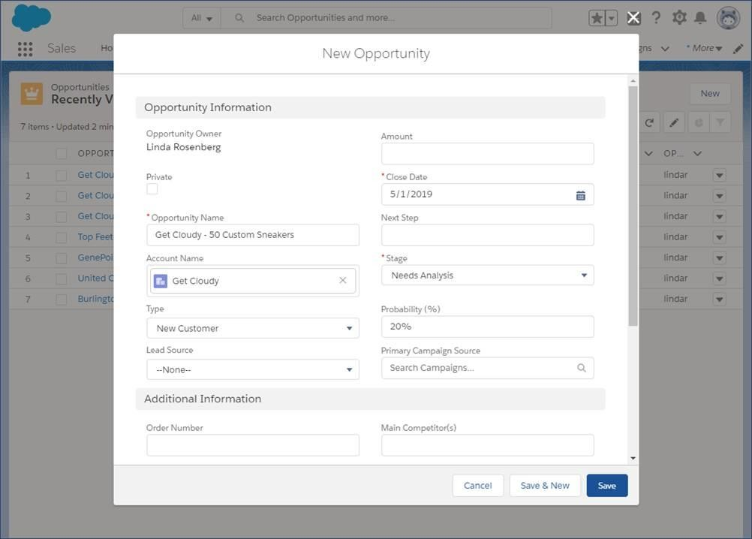

Not every company’s process is the same, so the stages your company uses for opportunities can differ from what you see in your Trailhead playground. Some companies set up separate sales processes for each type of sale that reps make. For example, Cloud Kicks can have one sales process to handle standard retail orders for large quantities, and another for small, custom orders.

Let’s start by creating an opportunity record where we can track our progress.

1. On the Opportunities tab, click New.
2. If your org has more than one record type for opportunities, select the type that best represents this opportunity.
3. Give the opportunity a name: Get Cloudy - 50 Custom Sneakers.
4. Select the account that the opportunity is related to.
5. Select a close date for the opportunity.
6. Select the opportunity’s current stage. For now, let’s use Needs Analysis. Salesforce adds a probability based on the stage selected. If the probability isn’t accurate, you can change it.
7. Click Save.

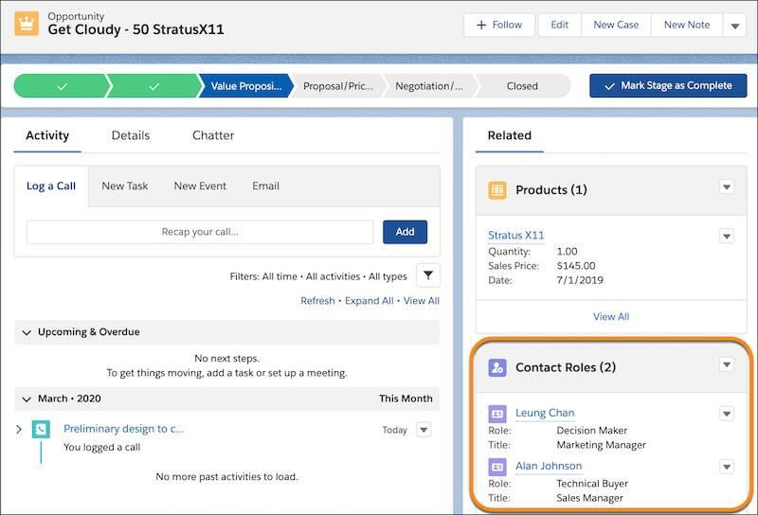

Congratulations! You’re on your way to closing a great deal. We discuss how to move this deal through the sales process in a bit. First, let’s talk about who’s involved in this deal.

## Contact Roles on Opportunities

Contact roles on opportunities tell you which contacts you’re dealing with and how each contact is related to the opportunity. You can also use contact roles to link contacts from other accounts to the opportunity.

You recently completed a deal with Get Cloudy Canada. You hear from Leung Chan, a decision maker from Get Cloudy, that she’s planning to talk to her Canadian colleague Lars about your product. For this sale, Lars is an Influencer. You can track that important information by giving Lars a role in the opportunity, even though he’s a contact on a different account.

If you’re following along and don’t see the Contact Roles related list, scroll down. Related lists can be displayed in a different order depending on how your admin arranged the page layout.

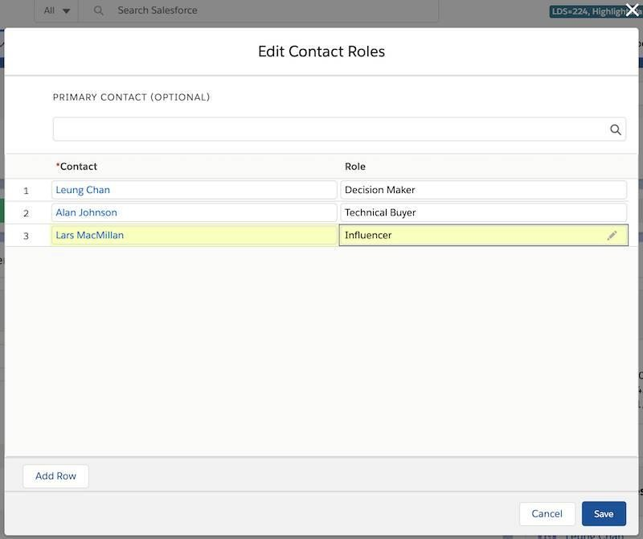

Take a minute to add Lars as a contact for the Get Cloudy Canada account. Then continue on to add his contact role for the opportunity you created.

1. In the Contact Roles related list of an opportunity, select Edit Contact Roles.
2. Enter a contact.
3. Choose a role. If you don’t select a role or the role is set to None, changes you make to this role aren’t saved.
4. If you like, select a primary contact for this opportunity.
5. Click Save.